# CREATION OF AN APPLICATION FOR SCHOOL MANAGEMENT - DEVELOPER - (SHORT-TERM)

Team ID : **LTVIP2023TMID11564**

Team Leader :KAMASANI ABHILASH

Team member : C .KRISHNAMOORTHI

# Profile

**Creation On Profile**

* From Setup enter Profiles in the Quick Find box
* Select Profiles.
* Click new, From the list of profiles, find Standard User (profile to clone) • For Profile Name, enter School Profile
* Click Save.
* While still on the School profile page, then click Edit.
* Scroll down to Custom Object Permissions and Give view all access permissions.

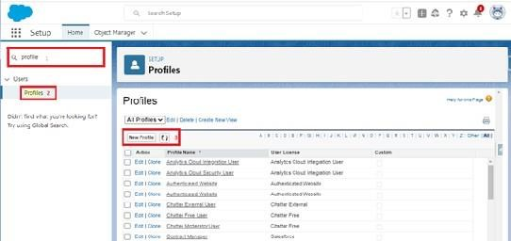

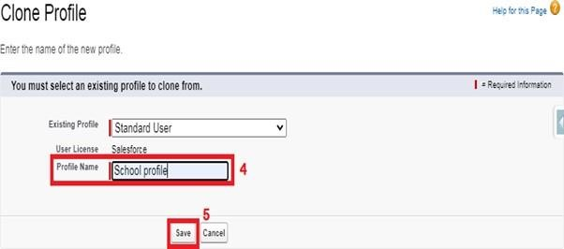

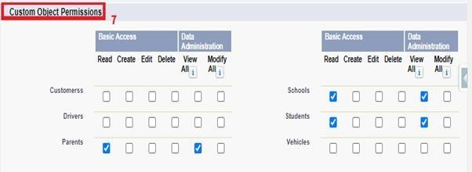

# Users

**Creating A User**

1. From Setup, in the Quick Find box, enter Users.
2. Select Users.
3. Click New User.
4. Enter the user’s name Parents and (Your) email address and a unique username in the form of an email address. By default, the username is the same as the email address.
5. Select a User License as salesforce.

1. NOTE- As Salesforce license can only be used by 2 Users at a time in Dev Org, so If you don’t find salesforce license then deactivate a user who has salesforce license or change the license type from Salesforce to any other.
2. Select a profile as a School profile.
3. Check Generate new password and notify the user immediately to have the user’s login name and a temporary password emailed to your email.
4. Similarly follow the above steps and create 2 users as Teachers and principals.

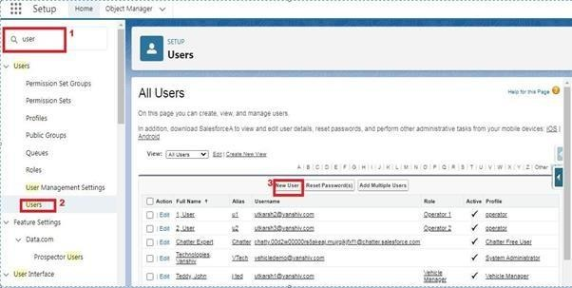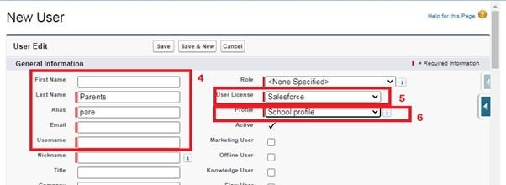

# Permission Sets

**Permission Sets 1**

1. From Setup, enter Permission Sets in the Quick Find box, then select Permission Sets.
2. Click New.
3. Give the name of the Permission set name as teacher permission.
4. Under the object settings give the view create and edit permissions to all 3 custom objects (By click open the object) 5. Click on manage assignment
5. Click on add assignment.
6. Click on Teacher (user), Next, Assign.

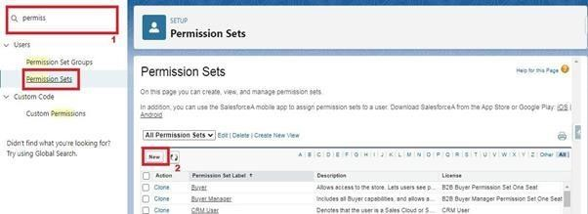

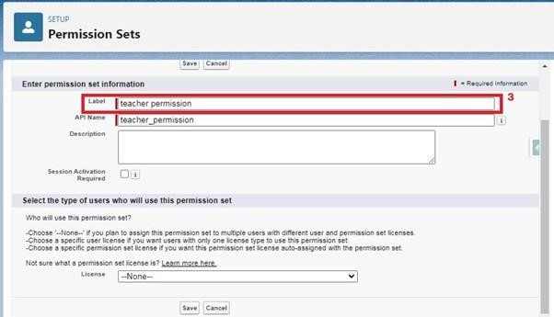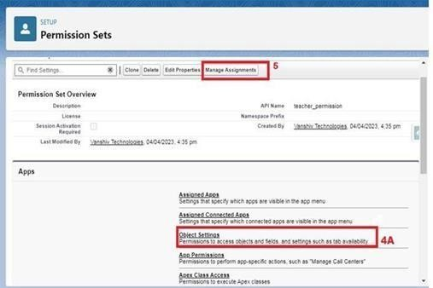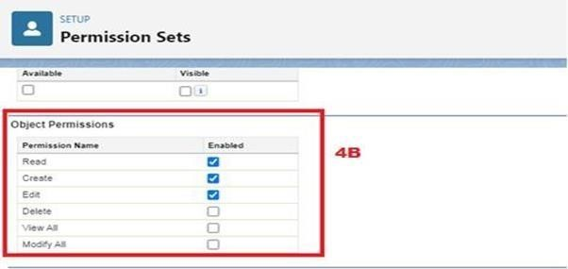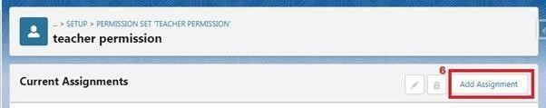

## Permission Sets 2

1. From Setup, enter Permission Sets in the Quick Find box, then select Permission Sets.
2. Click New.
3. Give the name of the Permission set name as Principal permission and then under the object settings give all permissions for the all 3

custom objects and assign them to the Principal user.